

**Advanced Databases**

Name =Akhil Pundir

Sap id=590016767

Course=BCA

Batch=3

Experiment-:1

Q1=Write a PL/SQL code to accept the value of A, B & C display which is greater.

Code-:

DECLARE

a NUMBER := 10;

b NUMBER := 25;

c NUMBER := 15;

BEGIN

IF a > b AND a > c THEN

DBMS_OUTPUT.PUT_LINE('A is greatest: ' || a);

ELSIF b > a AND b > c THEN

DBMS_OUTPUT.PUT_LINE('B is greatest: ' || b);

ELSIF c > a AND c > b THEN

DBMS_OUTPUT.PUT_LINE('C is greatest: ' || c);

ELSE

DBMS_OUTPUT.PUT_LINE('Two or more numbers are equal and greatest.');

END IF;

END;

/

Output-:

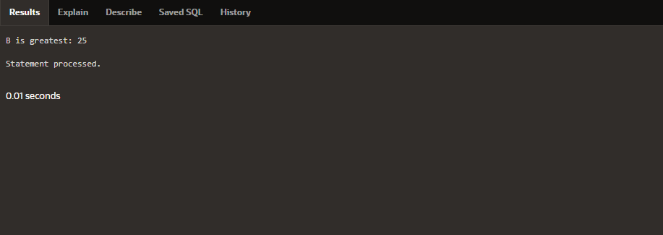

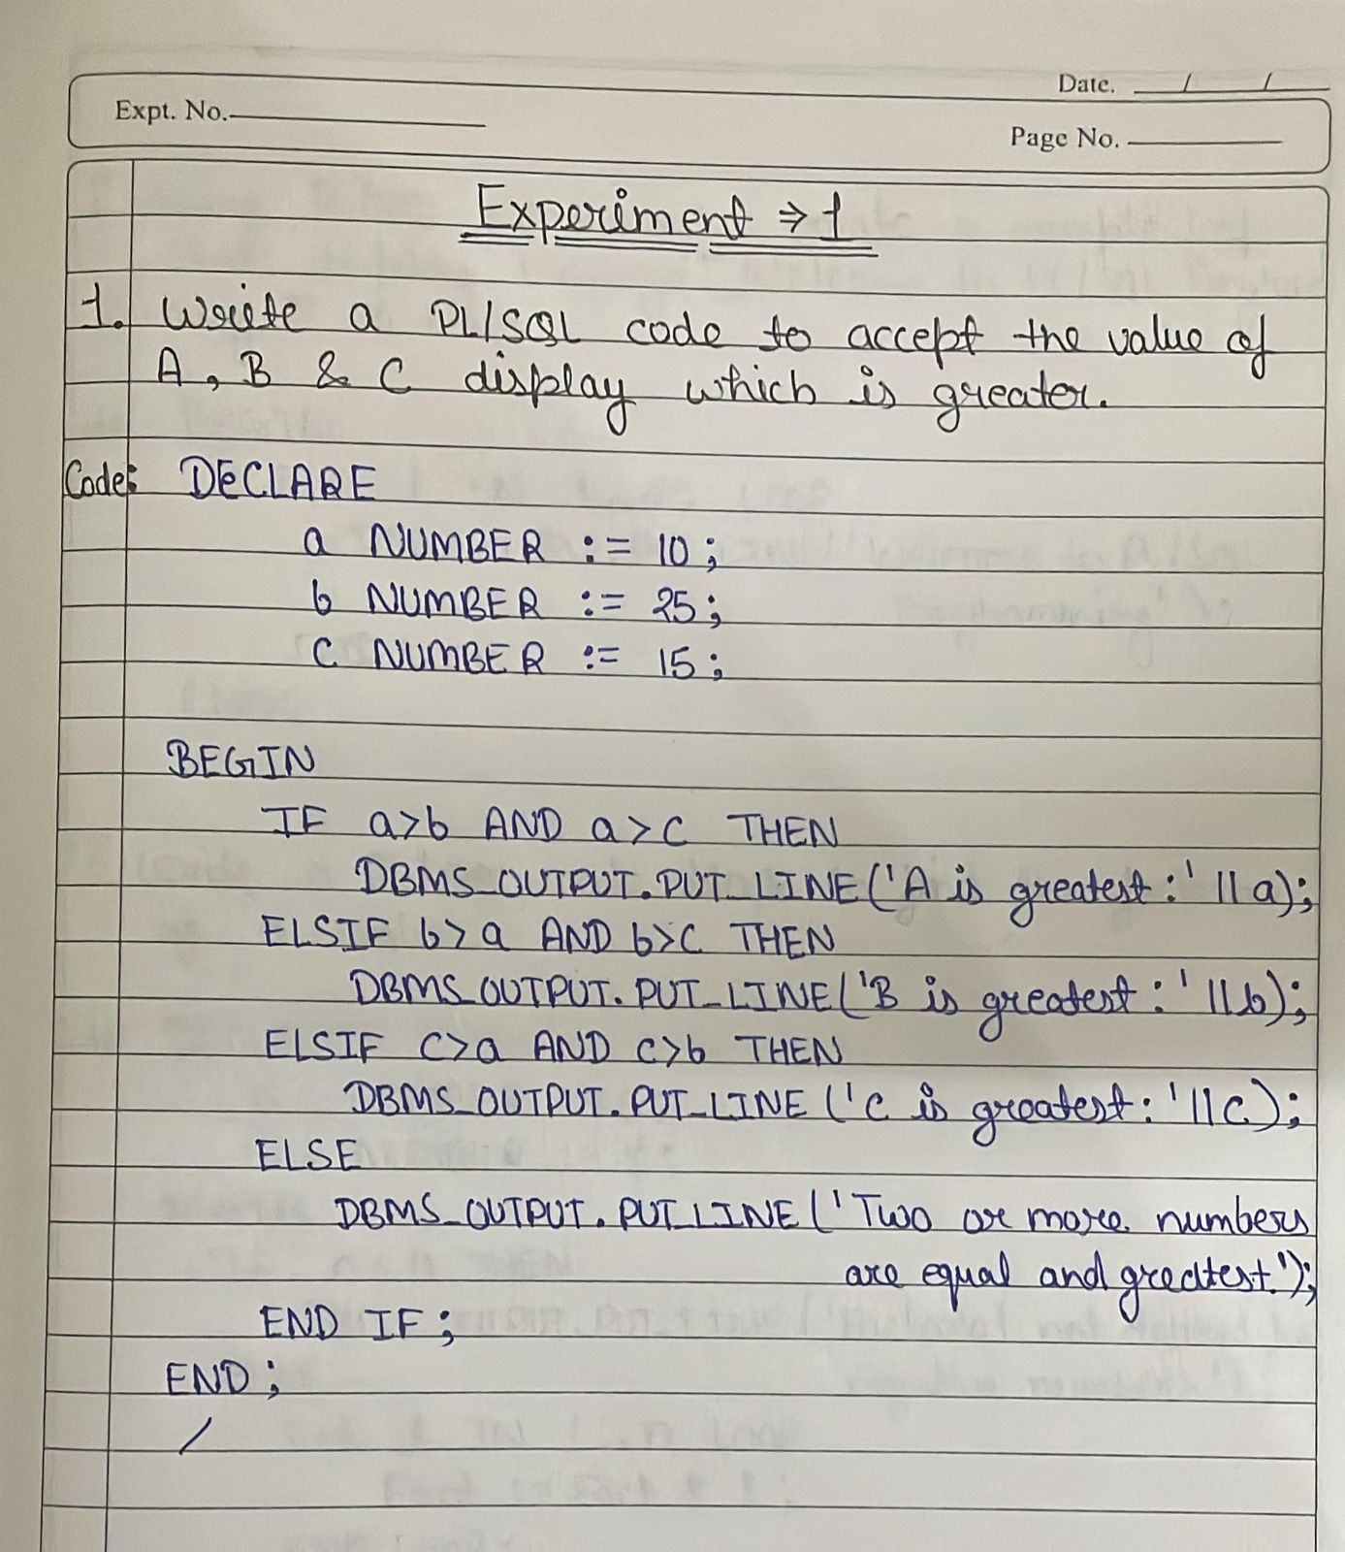

Q2=Using PL/SQL Statements create a simple loop that display message “Welcome to PL/SQL Programming” 20 times.

Code-:

BEGIN

FOR i IN 1..20 LOOP

DBMS_OUTPUT.PUT_LINE('Welcome to PL/SQL Programming');

END LOOP;

END;

/

Output-:

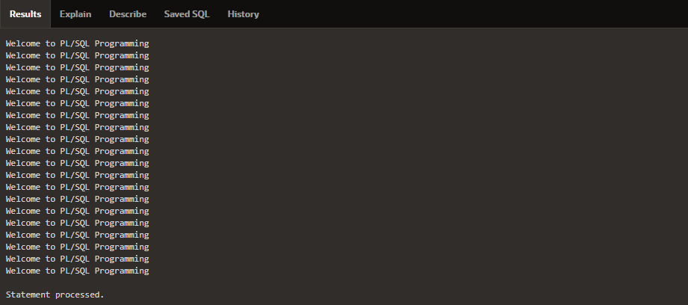

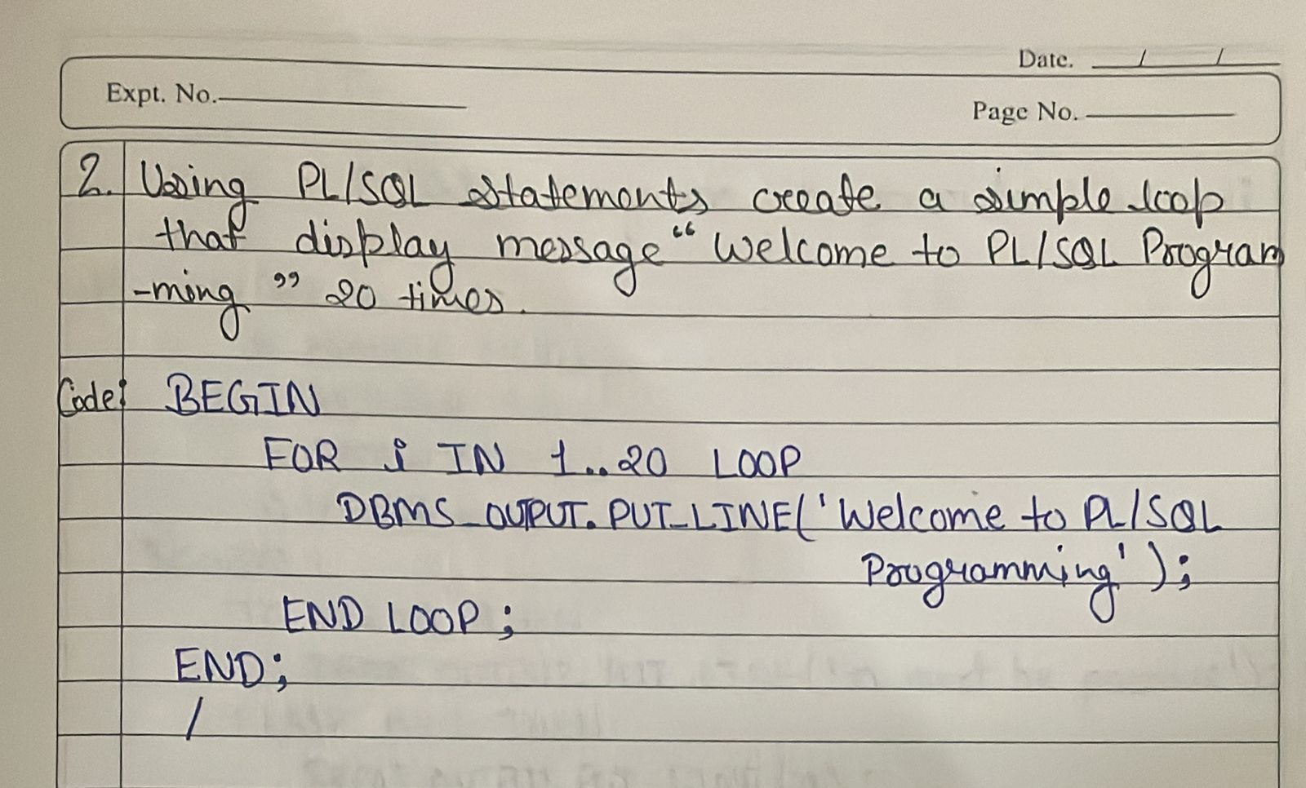

Q3=Write a PL/SQL code block to find the factorial of a number.

Code-:

DECLARE

n NUMBER := 5;

fact NUMBER := 1;

BEGIN

IF n < 0 THEN

DBMS_OUTPUT.PUT_LINE('Factorial not defined for negative numbers');

ELSE

FOR i IN 1..n LOOP

fact := fact * i;

END LOOP;

DBMS_OUTPUT.PUT_LINE('Factorial of ' || n || ' is ' || fact);

END IF;

END;

/

Output-:

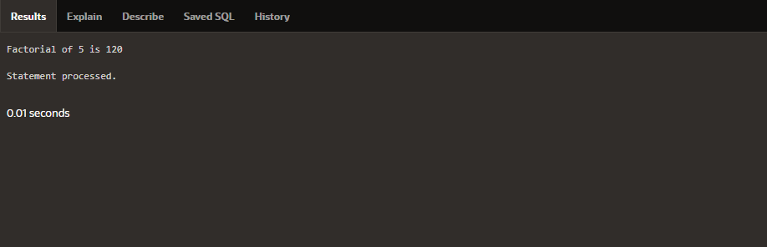

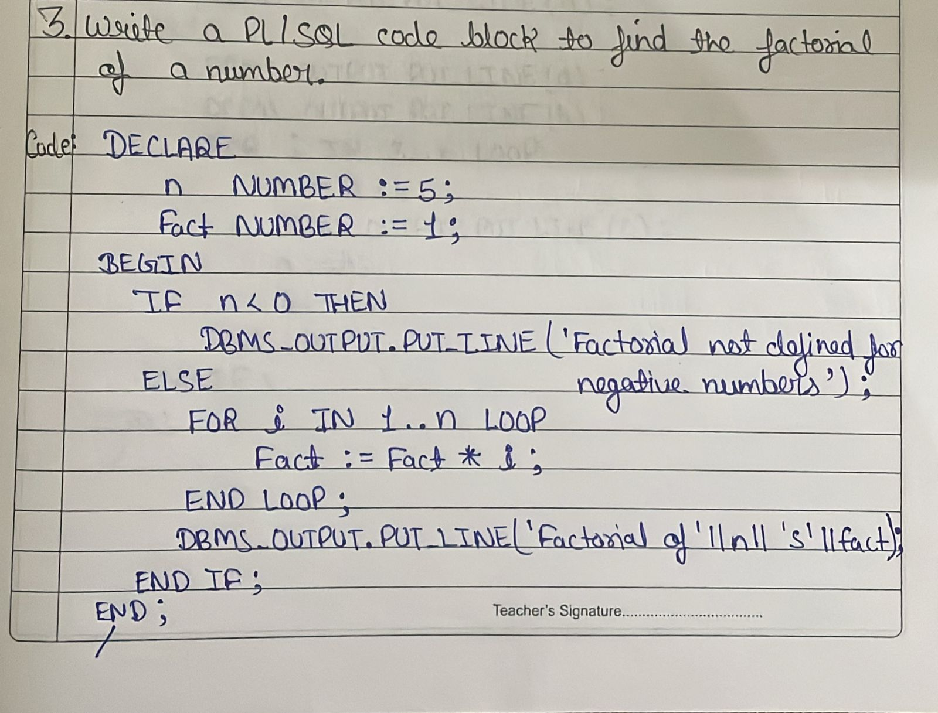

Q4=Write a PL/SQL program to generate Fibonacci series.

Code-:

DECLARE

n NUMBER := 10;

a NUMBER := 0;

b NUMBER := 1;

c NUMBER;

BEGIN

IF n <= 0 THEN

DBMS_OUTPUT.PUT_LINE('n must be positive');

ELSIF n = 1 THEN

DBMS_OUTPUT.PUT_LINE(a);

ELSE

DBMS_OUTPUT.PUT_LINE(a);

DBMS_OUTPUT.PUT_LINE(b);

FOR i IN 3..n LOOP

c := a + b;

DBMS_OUTPUT.PUT_LINE(c);

a := b;

b := c;

END LOOP;

END IF;

END;

/

Output-:

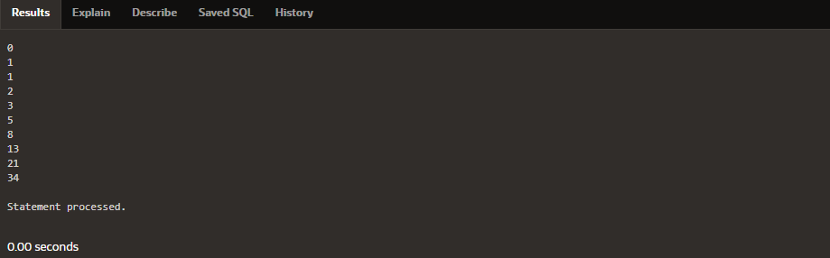

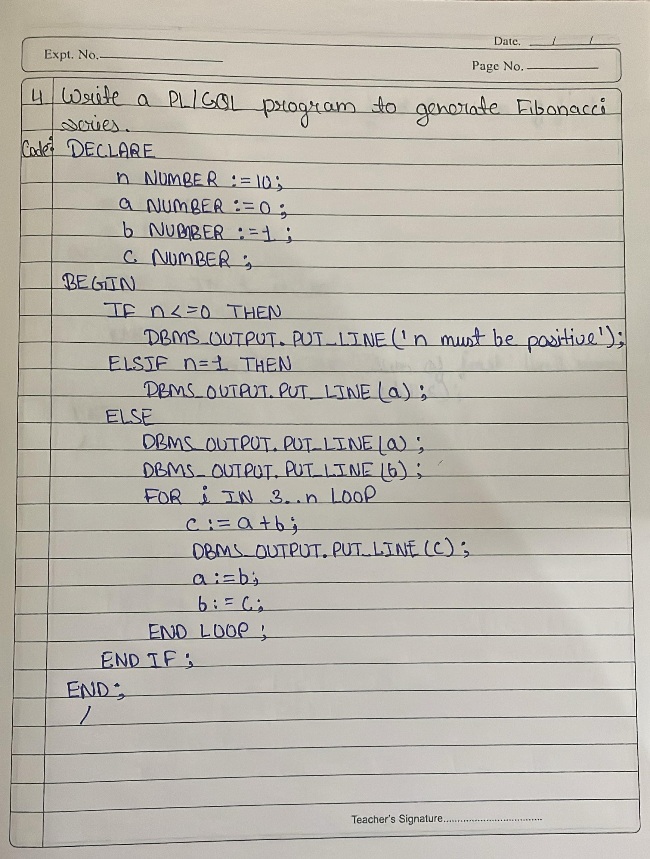

Q5=Write a PL/SQL code to fund the sum of first N numbers.

Code-:

DECLARE

n NUMBER := 10;

s NUMBER := 0;

BEGIN

FOR i IN 1..n LOOP

s := s + i;

END LOOP;

DBMS_OUTPUT.PUT_LINE('Sum of first ' || n || ' numbers is ' || s);

END;

/

Output-:

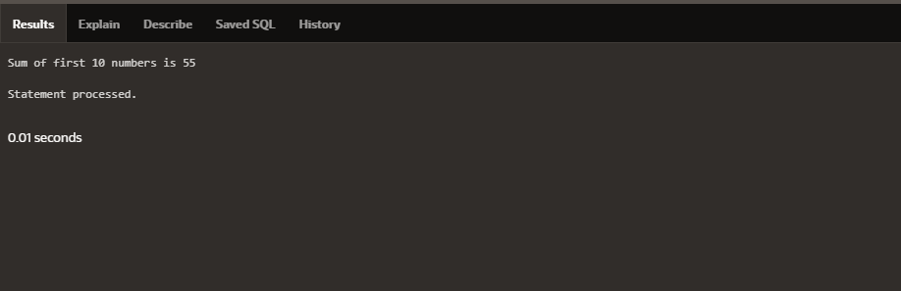

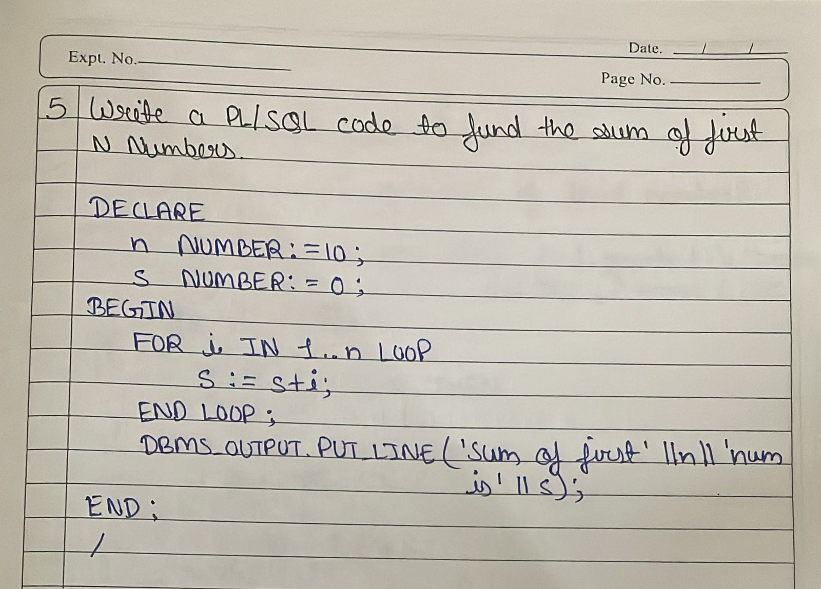

Experiment-:2

To understand concepts of Function and Procedure in PL/SQL

Q1= Find the greatest of A, B, C (Procedure).

Code-:

CREATE OR REPLACE PROCEDURE find_greatest(a NUMBER, b NUMBER, c NUMBER) IS

greatest NUMBER;

BEGIN

IF a > b AND a > c THEN

greatest := a;

ELSIF b > a AND b > c THEN

greatest := b;

ELSE

greatest := c;

END IF;

DBMS_OUTPUT.PUT_LINE('Greatest number is: ' || greatest);

END;

/

BEGIN

find_greatest(10, 25, 15);

END;

/

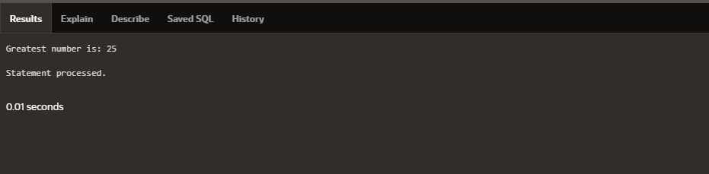

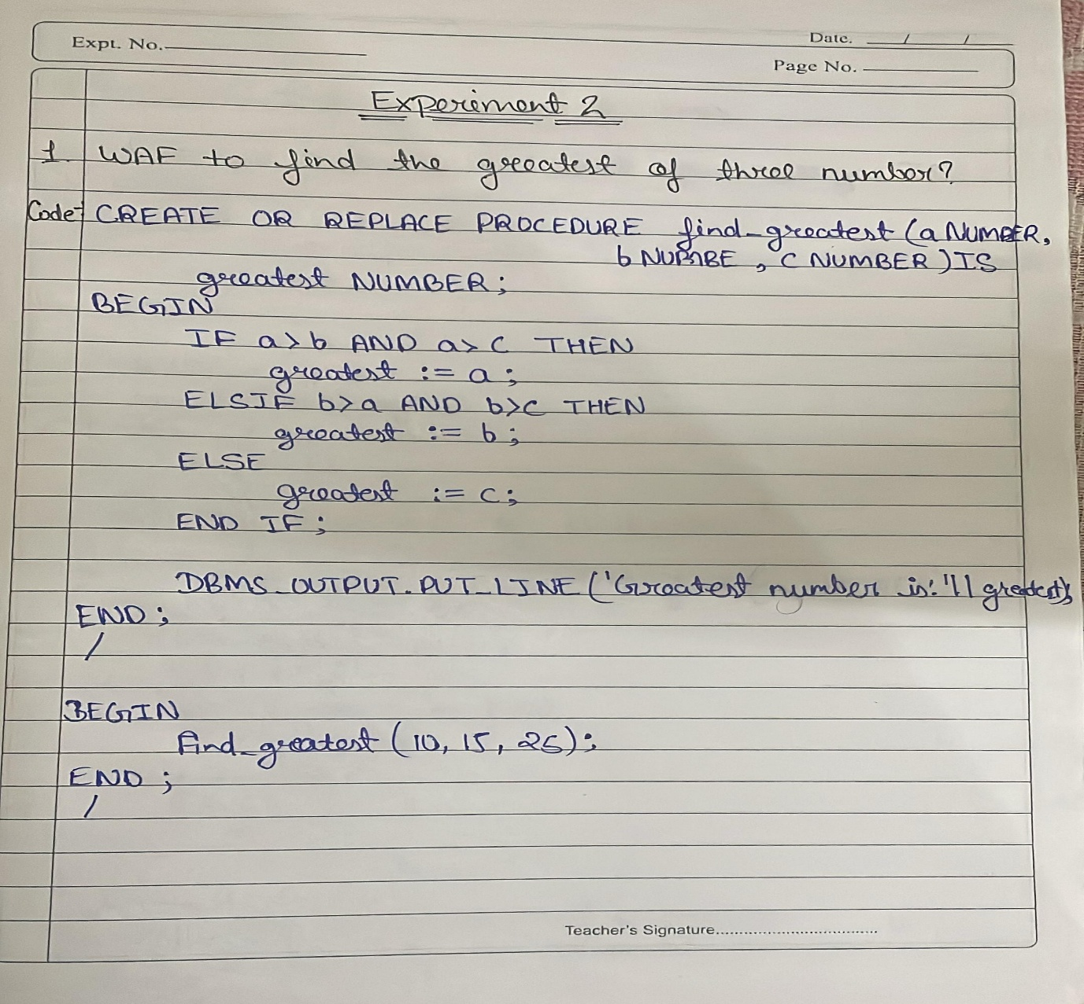

Q2= Display message 20 times (Procedure)

Code-:

CREATE OR REPLACE PROCEDURE print_message IS

BEGIN

FOR i IN 1..20 LOOP

DBMS_OUTPUT.PUT_LINE('Welcome to PL/SQL Programming');

END LOOP;

END;

/

BEGIN

print_message;

END;

/

Output-:

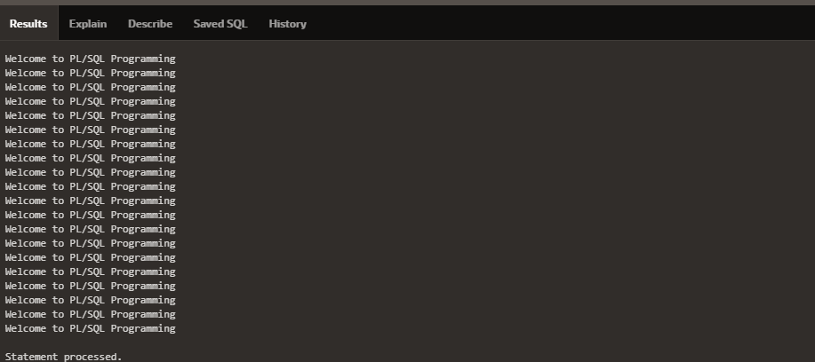

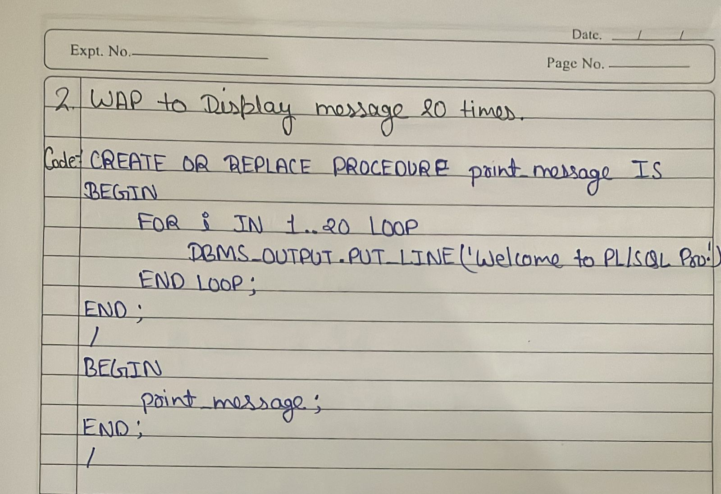

Q3= Factorial of a number (Function)

Code-:

CREATE OR REPLACE FUNCTION fact(n NUMBER)

RETURN NUMBER IS

f NUMBER := 1;

BEGIN

FOR i IN 1..n LOOP

f := f * i;

END LOOP;

RETURN f;

END;

/

BEGIN

DBMS_OUTPUT.PUT_LINE('Factorial is: ' || fact(5));

END;

/

Output-:

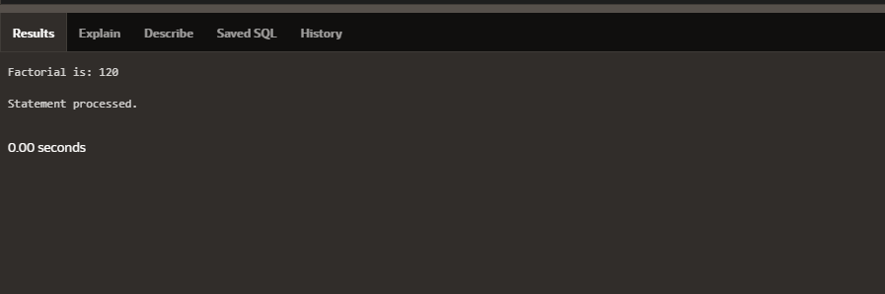

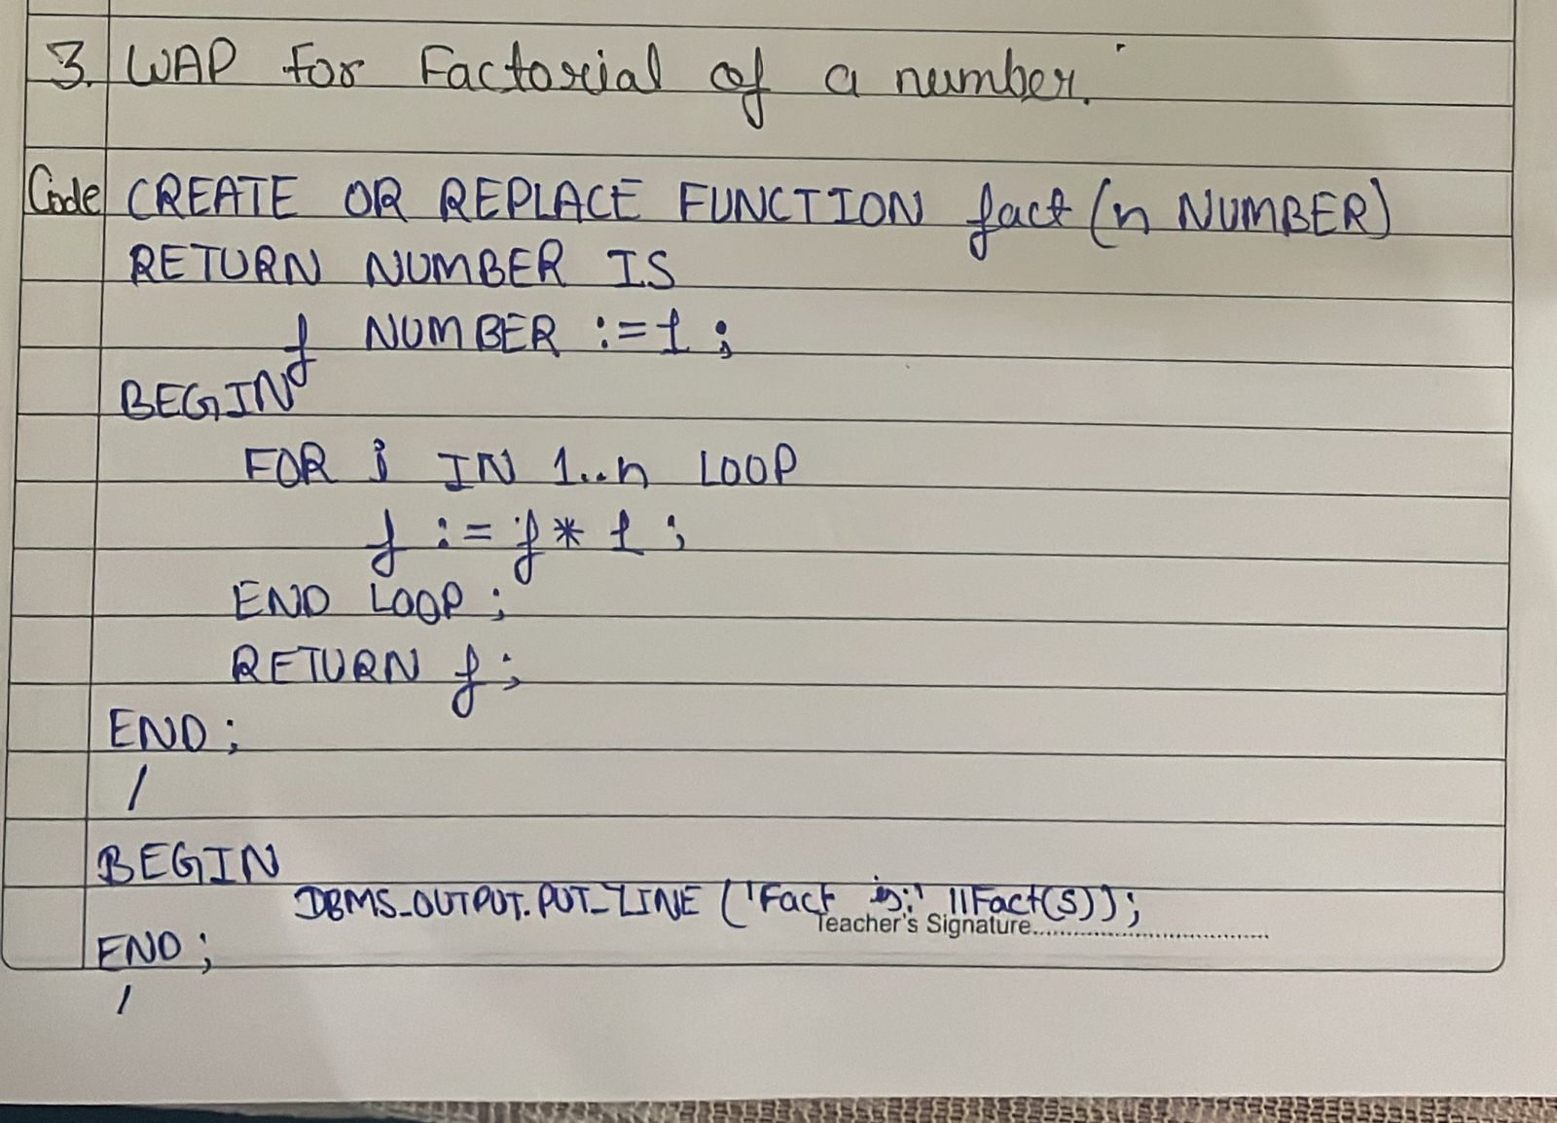

Q4= Fibonacci series (Procedure).

Code-:

CREATE OR REPLACE PROCEDURE fibonacci(n NUMBER) IS

a NUMBER := 0;

b NUMBER := 1;

c NUMBER;

BEGIN

DBMS_OUTPUT.PUT_LINE('Fibonacci series:');

DBMS_OUTPUT.PUT_LINE(a);

DBMS_OUTPUT.PUT_LINE(b);

FOR i IN 3..n LOOP

c := a + b;

DBMS_OUTPUT.PUT_LINE(c);

a := b;

b := c;

END LOOP;

END;

/

BEGIN

fibonacci(10);

END;

/

Output-:

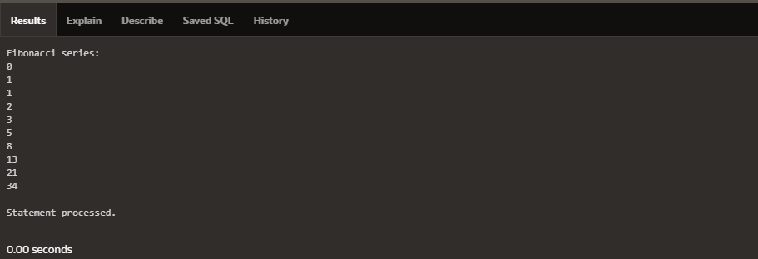

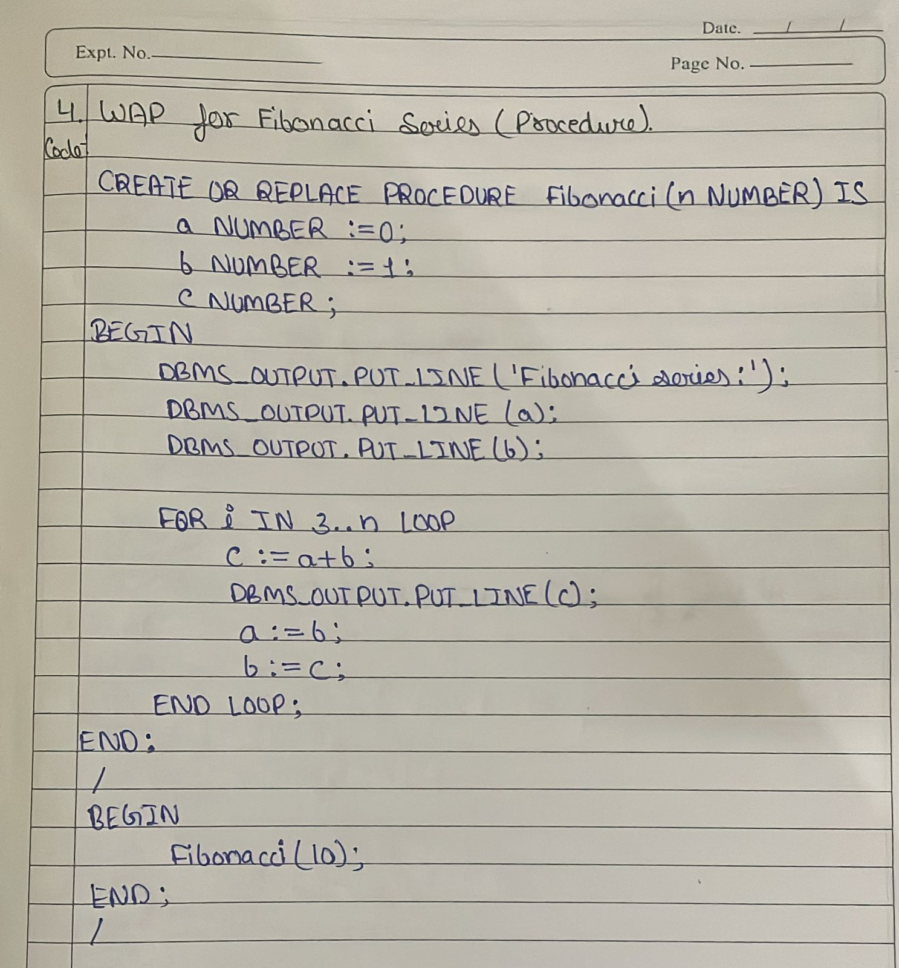

Q5= Sum of first N numbers (Function).

Code-:

CREATE OR REPLACE FUNCTION sum_n(n NUMBER)

RETURN NUMBER IS

s NUMBER := 0;

BEGIN

FOR i IN 1..n LOOP

s := s + i;

END LOOP;

RETURN s;

END;

/

BEGIN

DBMS_OUTPUT.PUT_LINE('Sum of first 10 numbers is: ' || sum_n(10));

END;

/

Output-:

